Concept Summery
- In 3-4 paragraphs, summarize the key ideas you’ve learned in this module.
I things I learned in this week module for my RSA is that trying to learn new skills takes time and depending on how you manage it you can get a basic grasp of the skill and grow form there. Writing out the parts that need first in order to create my project will help in the long run because you know what needs to be done first.
I also learned that you shouldn’t doubt yourself and trust yourself to get things done. Keeping practicing and asking questions, research the topics you don’t know well. I kept pushing to get the job done and I eventually got where I wanted to go. I will say that it was challenging though because when I got stuck and thing did not work right, I got frustrated and would need to take a break. I really enjoyed this assignment because it got me to take the initiative and do something that I have been putting off because I was too afraid that I wouldn’t be able to do the work.
I was able to get some resources for the thinking strategies for the project, but we unfortunately didn’t go over any game programming subject in the class. The game design though did help me with coming up with ideas for this project and I was able to take some concepts from it to use for my inventory system.
- In 1-2 paragraphs, explain for YOU what is the purpose of learning this content. In other words, what will you be able to do with it? What problems will you be able to solve if you master the key skills you are learning?
The purpose of this was to teach me something new that I have been wanting to learn but kept pushing back. I was able to get the basic skills needed to create my inventory system. I will be able to create a better system for my future projects that have items that the player can use to do things. This project helped me think of things outside the box and come up with new ways to tackle a problem.
Midpoint
- In 3-4 sentences, IN YOUR OWN WORDS, explain the project. What study/prep must be done, what skills must be learned, and what defines a successful result?
I need to know how the unity engine works and how to code in C# sharp to create an inventory system for a player. However, you need a few other things first in order for it to work. I need to have a decent playing field that the items and sit on and the player has well. I also need to have a character that can move around and collide with objects. I then need to create a pickup script that would have the items in a list where I could pick them up. I would then need to research and look up how to create an inventory system that would allow me to store items and display them in a ui grid.
- In 3-4 sentences, explain the basics of the thinking strategy being used for this assignment. What is it called, and what steps are taken to use it?
Some of the thinking strategies I used was creative thinking because I had to think of ways to solve the issues had without having to start over. I did use vertical thinking strategies because I knew that I needed to have a character who can move and interact with objects in order to create an inventory system. I also used ongoing thinking for researching ways to create the system and questioning if this were the right way to do it. Some of the blocks I had though was Learned helplessness where I felt like I wasn’t good enough, but I kept pushing and learned how to create a good system.
- In 1-2 sentences, list what you’ve accomplished so far for this project.
I researched what I would need to create a system and started to create the level, by making the character move around and interact with objects. I also made sure that I understood what I was doing so I could recreate this in the future.
- In 1-2 sentences, list what you still need to accomplish to successfully complete the project.
I still need to create some assets and create the inventory system where you can pick up items and use them. I need to create the Ui system to showcase that the items are being picked up.
- Is there anything you’re struggling with? Do you need any help?
The part I was struggling with is getting the items to stack if they are the same item. Other than that, I am fine, and I don’t think I need any help. I will research and see if I can find a video or a solution to the problem.
Project Reflection
- Did you accomplish the assignment successfully? Why or why not?
Yes, I was able to create the inventory system that works for a beginning level. I will be able to take this knowledge and use it on my future projects and create a better system then before.
- What went right in the prep and execution of the project?
The things that went right is that the movement and the scripts were coming together with almost no bugs and did not need to ask a lot of help. I created the setting and the art looked nice and the ui came together well.
- What went wrong?
The things that went wrong for me was the stacking of items I tried to get it where if you picked up the same items it would stack. I didn’t have any issues with the software.

- What did you learn about the thinking strategy you used?
The vertical thinking helped me think what's needs to be done first in order to get my goals accomplished. This will help me in future project because in programming there is some paths you need to take to get things done but you can use lateral thinking to think of different ways to code the thing I need. An example is making my code for efficient or designer friendly for everyone.

- Based on your lessons learned, what do you plan to do differently on the next project?
I think that in order to complete a coding concept I should start a little sooner or plan out a bit on paper what all I need in order to create the system. I will learn a better way to make the inventory system more understandable and efficient.

The final product
Inventory Management
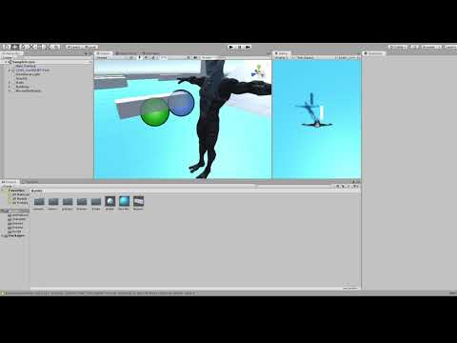

Links
Strategies used
https://synchronic.uat.edu/courses/4217/pages/systems-thinking-2?module_item_id=380851
Got some info
https://medium.com/@yonem9/create-an-unity-inventory-part-1-basic-data-model-3b54451e25ec
https://www.mvcode.com/lessons/unity-rpg-inventory-system-jamie

