Description of game
You are a traveler who stumbled upon a town called Wimpy town. You met a man named Tod. He has you find and deliver metal to a man named Oswald to work on his home and upgrade it. After that Oswald has you head to Turkindale.
Goals to complete task.
You will have to collect gold, find metal and buy metal from the shop to complete your task. You can fight enemies to earn more gold to complete your task.
Genre - Action RPG
Caster Skills
Ice shard
Fireball
Healing Spell
Lighting Ball
Knight Skills
Downward swing
360 swing
Level and layout design for game.
Level 1

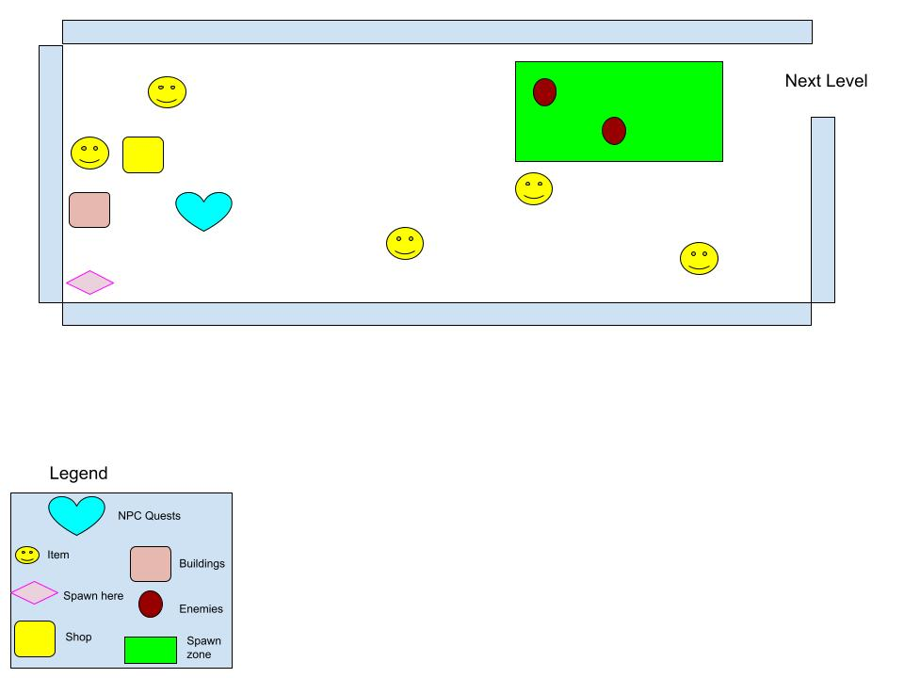

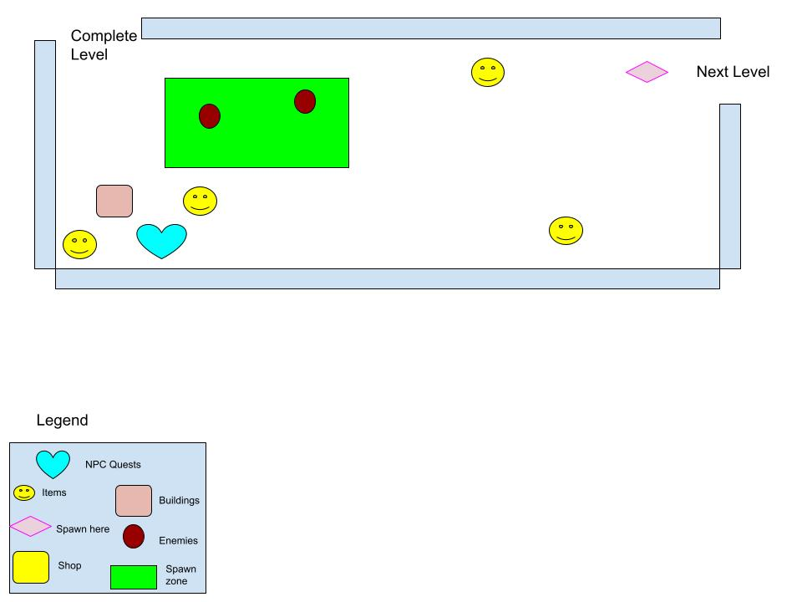
Level 2

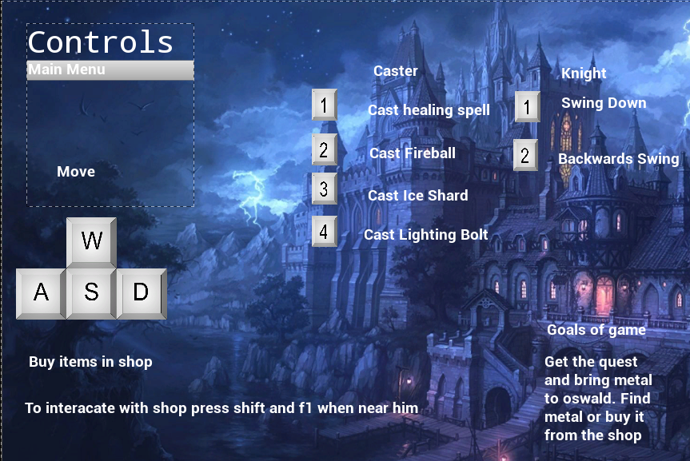
Controls to the game
Blueprints
Level 1 and level 2 have the same blueprints.
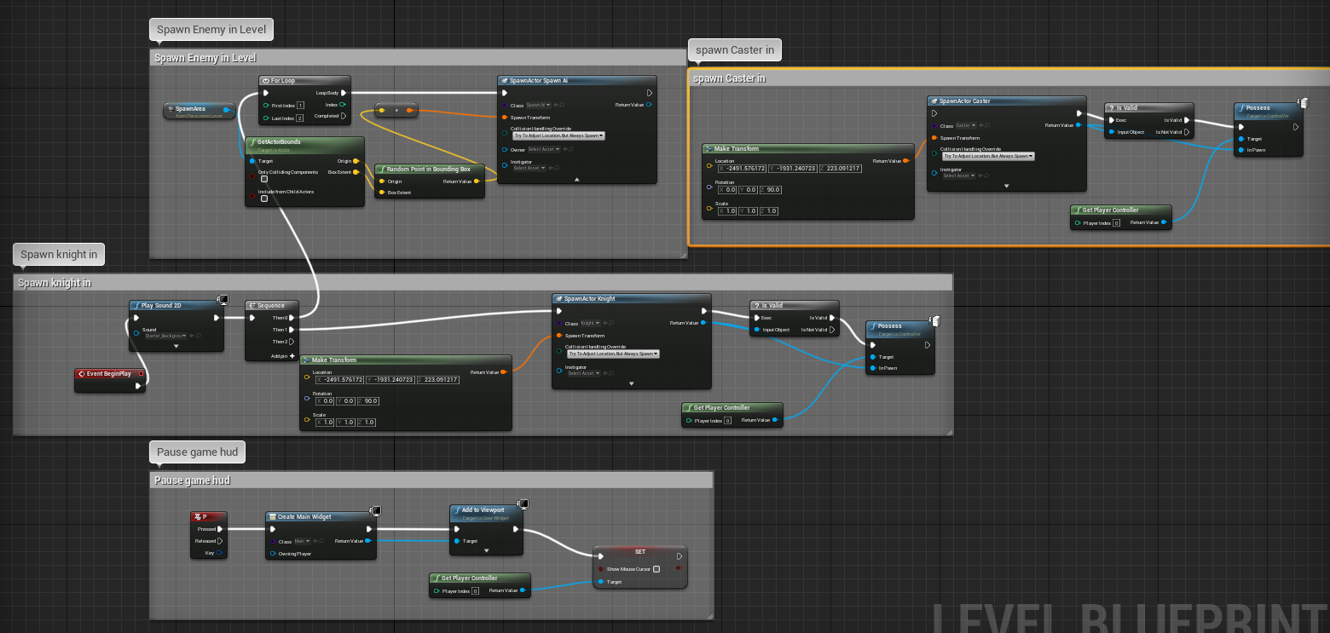
Characters
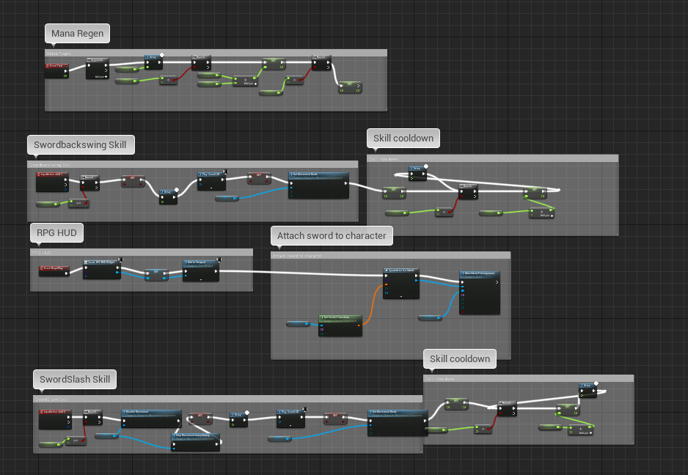
Knight Blueprints

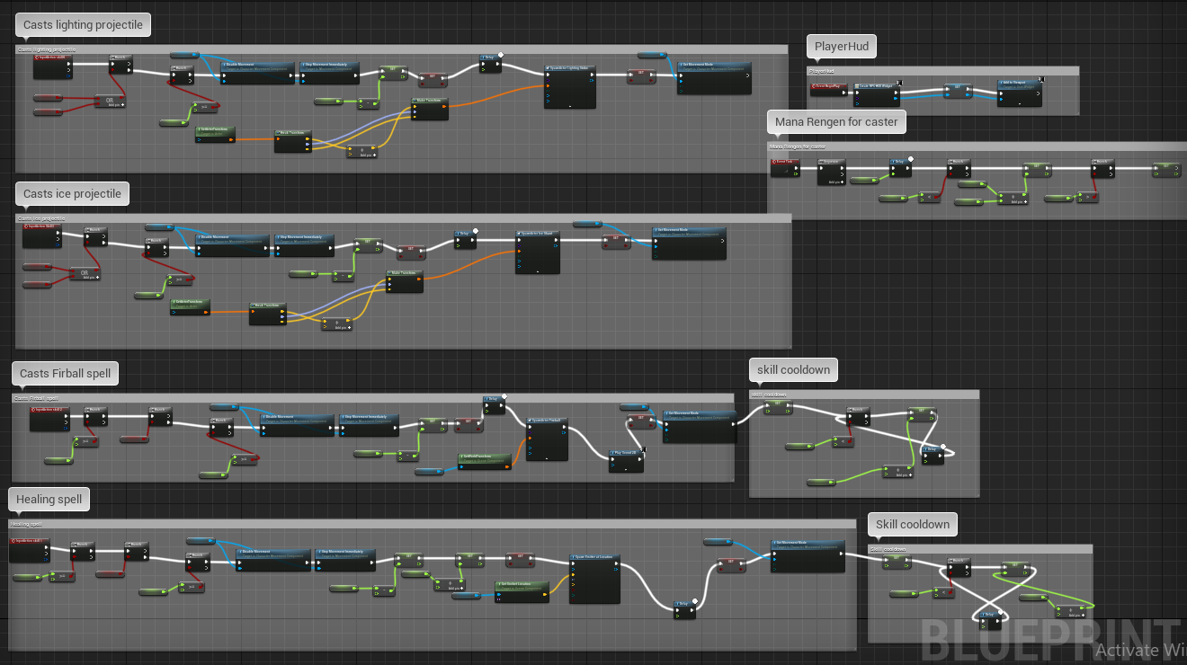
Caster Blueprints
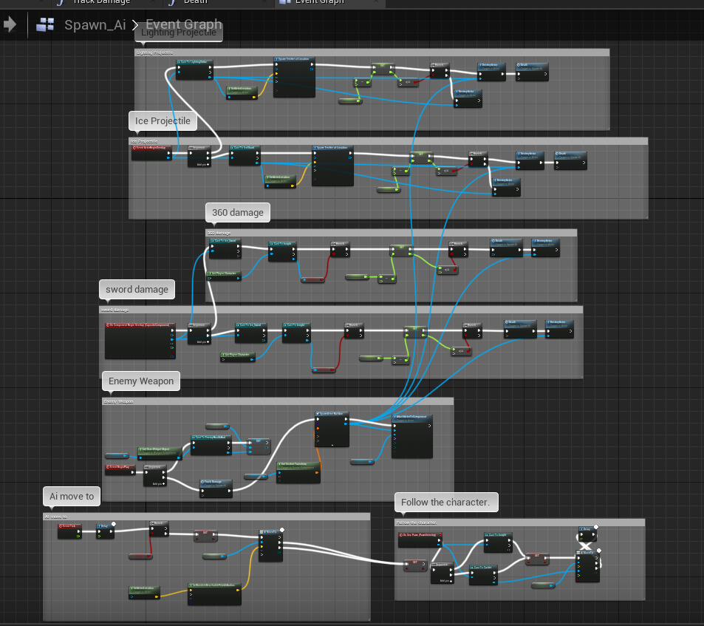
Enemy
Animations and state
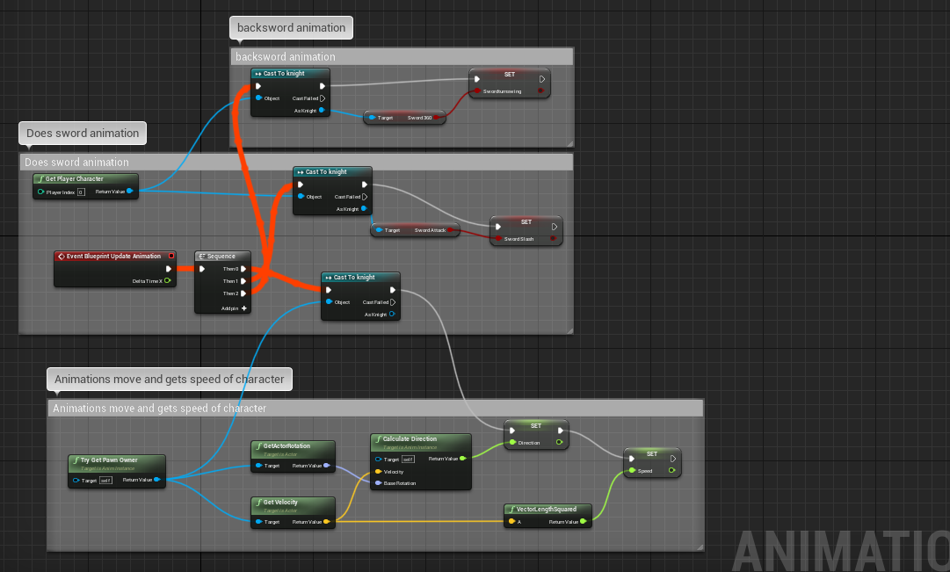
Knight

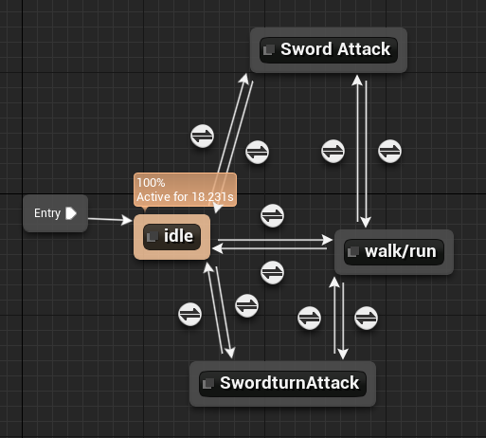
Caster
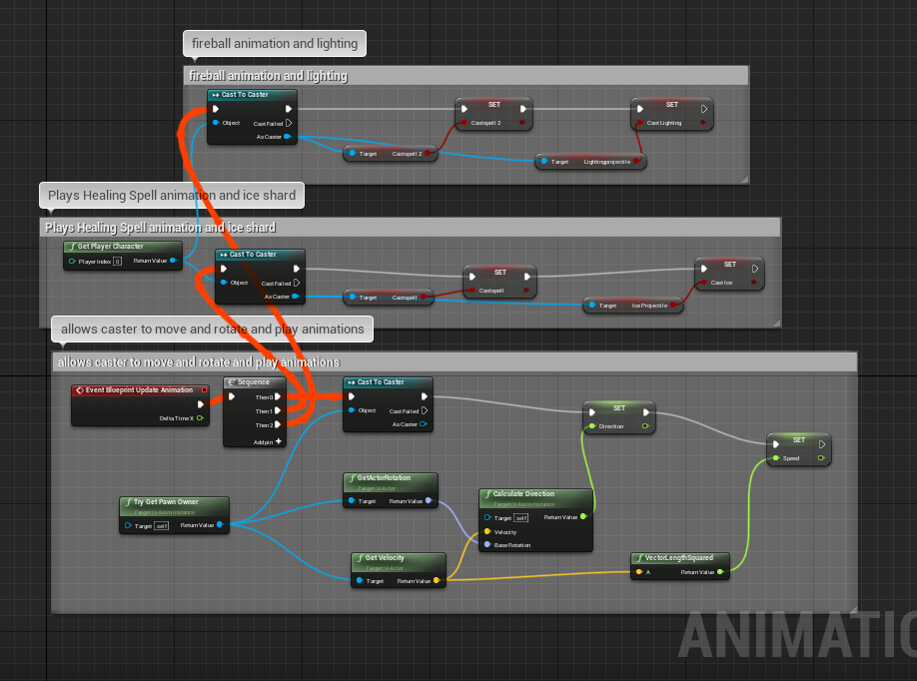
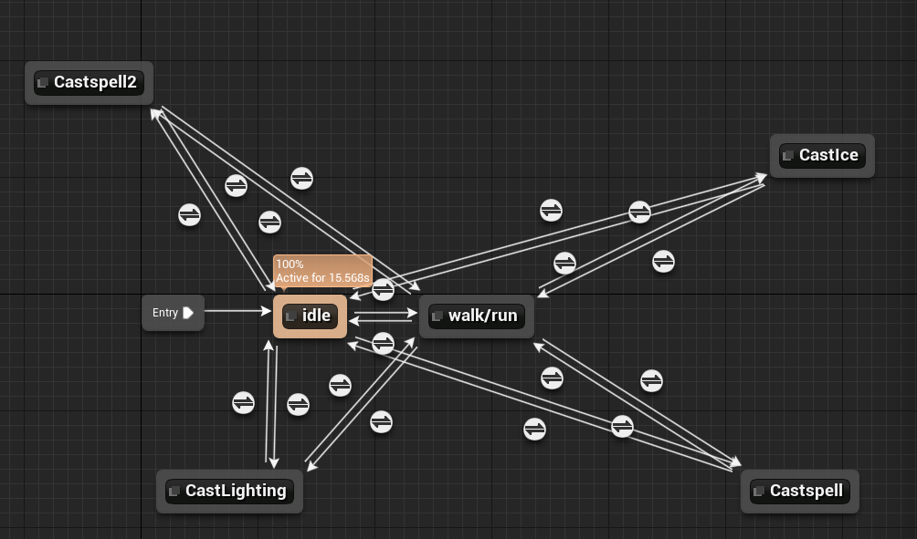

Pickups
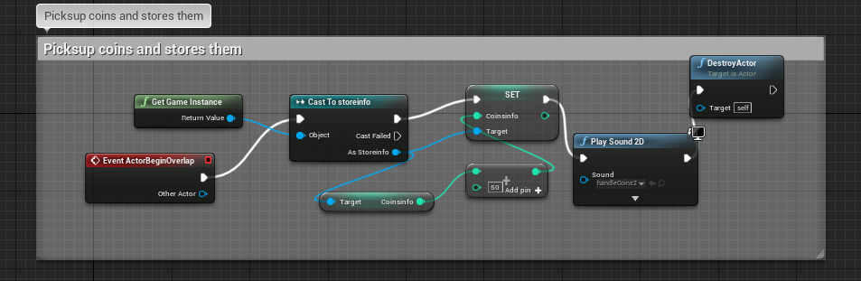
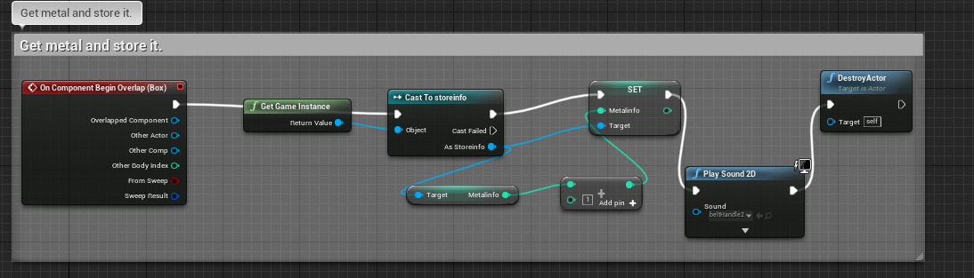
Metal, Gold is the same set up.
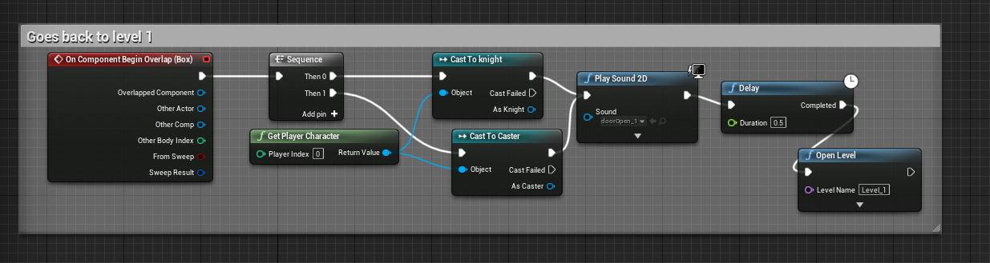
Doors all have similar code only difference is going to different levels or completing them.

Health
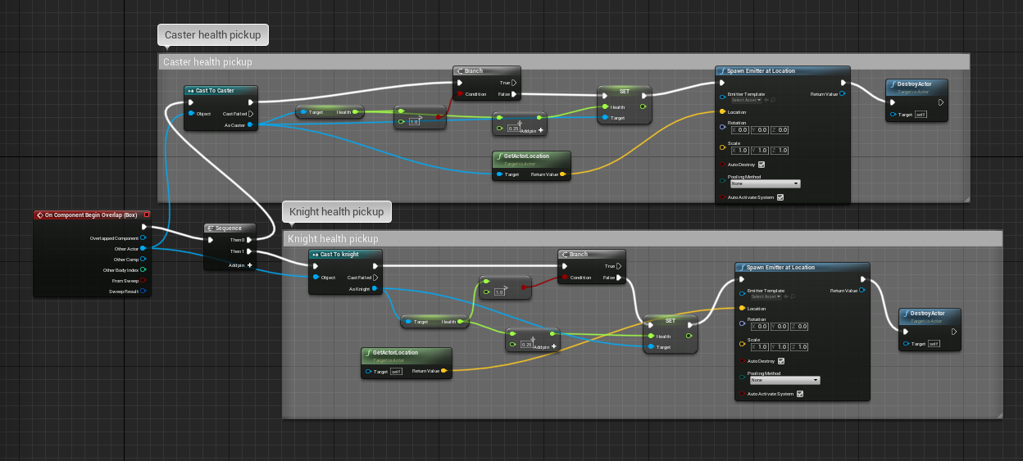
Quests
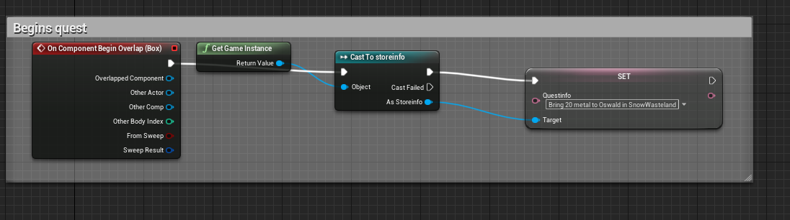
Quest 1
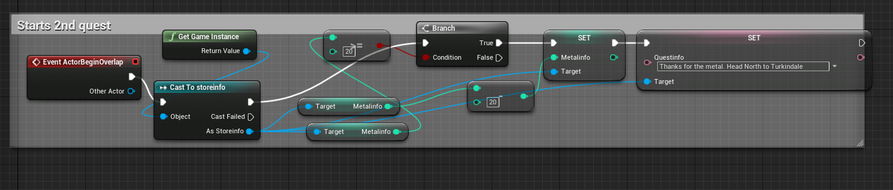
Quest 2

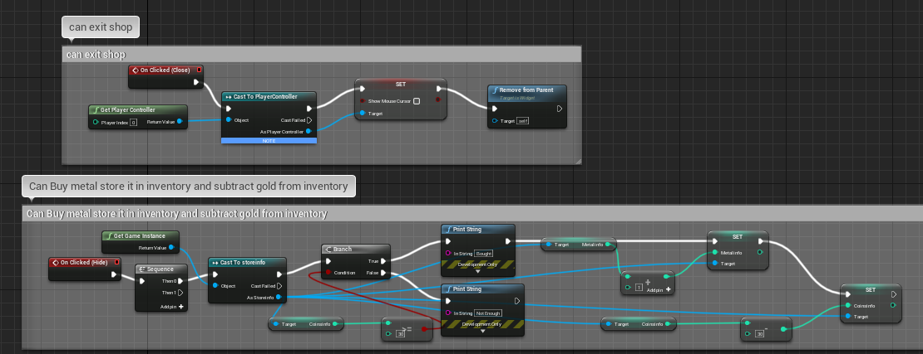
Shop

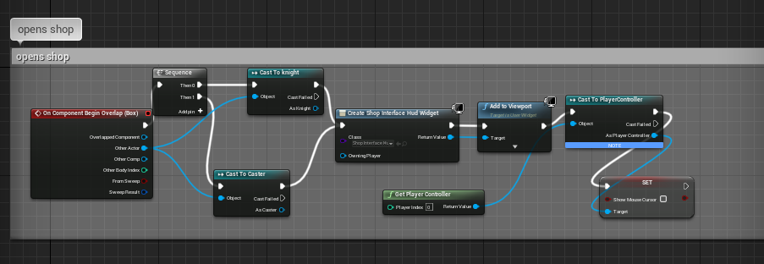
RPG Hud
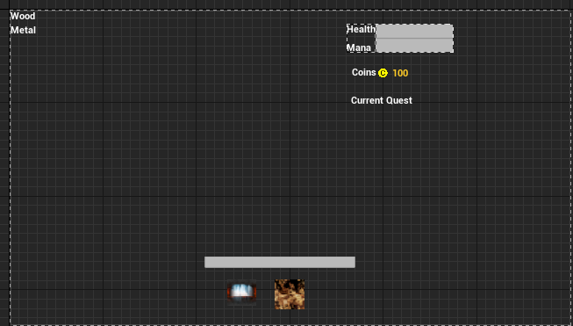

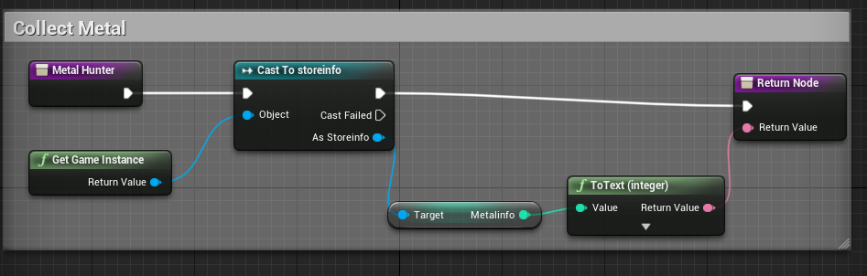
Metal, shop, and quest are the same for code. Just different target
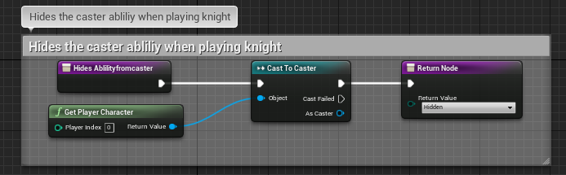
The knight and caster code are the same just for characters.
Health and mana are the same just different variables.
